|  |  |
| --- | --- |
| **EXP : 5** | **SIGN UP FORM – POST METHOD** |

**AIM:**

To develop a Java Servlet program that handles user input from a **sign-up form** using the **POST method**, retrieves the submitted data (such as first name, last name, date of birth, address, and gender), and displays the details back to the user in a structured HTML format.

**CODE:**

**SignUp.html:**

<!DOCTYPE html>

<html lang=*"en"*>

<head>

<meta charset=*"ISO-8859-1"*>

<title>Sign Up Form</title>

</head>

<body>

<form action=*"/shriram/SignupDetails"* method=*"post"*>

<label for=*"fname"*>First Name:</label>

<input type=*"text"* id=*"fname"* name=*"fname"*>

<br>

<br>

<label for=*"lname"*>Last Name:</label>

<input type=*"text"* id=*"lname"* name=*"lname"*>

<br>

<br>

<label for=*"dob"*>Date of Birth:</label>

<input type=*"date"* id=*"dob"* name=*"dob"*>

<br>

<br>

<label>Gender:</label>

<input type=*"radio"* id=*"male"* name=*"gender"* value=*"male"*>

<label for=*"male"*>Male</label>

<input type=*"radio"* id=*"female"* name=*"gender"* value=*"female"*>

<label for=*"female"*>Female</label>

<br>

<br>

<label for=*"address"*>Address:</label>

<textarea id=*"address"* name=*"address"*></textarea>

<br>

<br>

<br>

<br>

<input type=*"submit"* value=*"Sign Up"*>

</form>

</body>

</html>

**SignupDetails.java:**

package com.shriram.servlet;

import java.io.IOException;

import java.io.PrintWriter;

import javax.servlet.ServletException;

import javax.servlet.annotation.WebServlet;

import javax.servlet.http.HttpServlet;

import javax.servlet.http.HttpServletRequest;

import javax.servlet.http.HttpServletResponse;

/**

* Servlet implementation class SignupDetails

*/

@WebServlet("/SignupDetails")

public class SignupDetails extends HttpServlet {

private static final long serialVersionUID = 1L;

/**

* @see HttpServlet#HttpServlet()

*/

public SignupDetails() {

super();

}

/**

* @see HttpServlet#doGet(HttpServletRequest request, HttpServletResponse response)

*/

protected void doGet(HttpServletRequest request, HttpServletResponse response) throws ServletException, IOException {

}

/**

* @see HttpServlet#doPost(HttpServletRequest request, HttpServletResponse response)

*/

protected void doPost(HttpServletRequest request, HttpServletResponse response) throws ServletException, IOException {

String fname = request.getParameter("fname");

String lname = request.getParameter("lname");

String dob = request.getParameter("dob");

String gender = request.getParameter("gender");

String add = request.getParameter("address");

PrintWriter p = response.getWriter();

p.println("First Name: " + fname );

p.println("Last Name: " + lname );

p.println("DOB: " + dob );

p.println("Gender: " + gender );

p.println("Address: " + add);

}

}

**OUTPUT:**

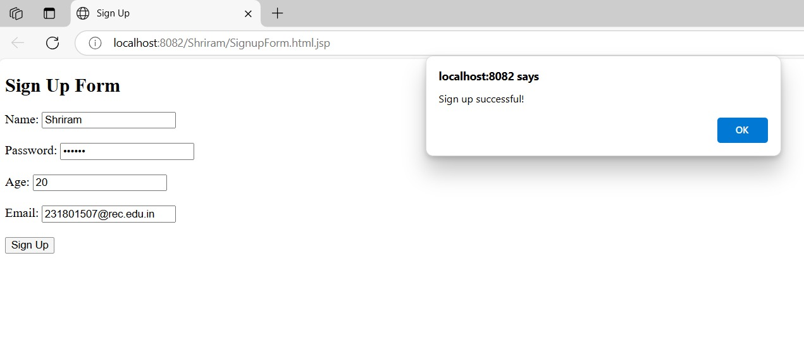

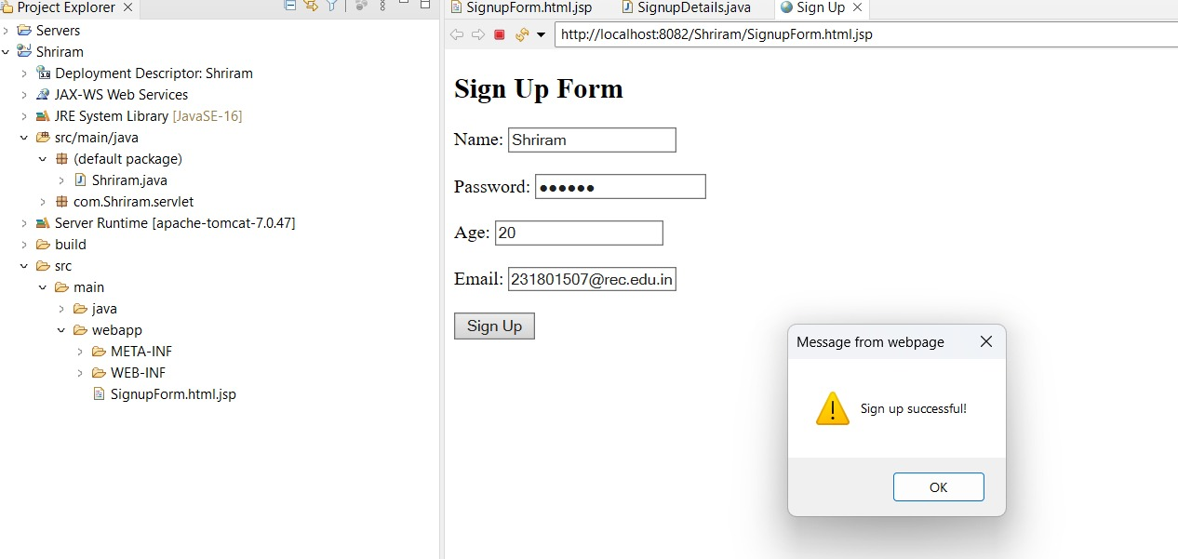

**RESULT:**

Handling signup form using the post method has been Executed Successfully.